Magic Invitational Report: Kai Budde
Kai Budde
Last years Magic: The Gathering Invitational in Sydney was a blast. I enjoyed Australia in general and the people were great. I looked forward for this years event in Cape Town since I left Sydney a year go.

The People
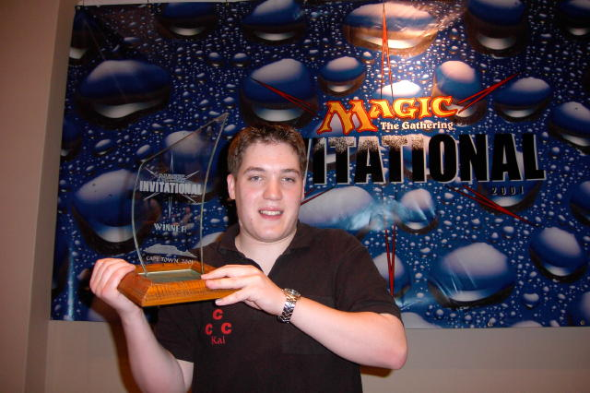
Gary Wise, Scott Johns, Antoine and Olivier Ruel, Tom van de Logt, Kamiel Cornelissen, Chris Pikula, Jon Finkel, Dave Price, Dan Clegg, Brian Kibler, Mike Pustilnik, Chris Benafel, Scott Richards and Tsuyoshi Fujita promised to make that a very good time. Unfortunately my teammate Zvi Mowshowitz had to resign from his deserved slot but he wasn't too bitter as he got replaced by friend and teammate Scott Johns. Ryan Fuller also resigned from his slot - mostly for personal reasons as he preferred to play in the Grand Prix and also because his invitation would go to his friend Olivier 'mostly known as Antoine Ruel's brother' Ruel.
In Sydney, we had a 'local guide' that I knew from the Pro Tour: The Ben Seck. He showed Gary and me some stuff in the city. We got there a little early to sightsee and we had a great time. This time Gary and I got in three days earlier again. And we knew a local player in Cape Town, too - Andrew Mitchell (it seemed like one out of every two South African Magic players was named Andrew). Scott Richards and his friend James White got in on Saturday too. In Sydney, it was TBS (Ben Seck) who loaned tons of cards to the Invitational players who didn't bring all the cards they eventually needed. This year it was James's turn. He had a ridiculous amount of cards on him and even brought a full Odyssey set in case we wanted to practice the Rotisserie-draft! But TBS apparently was quite afraid that without him no one would have a Constructed deck, so he showed up anyway.
With the 16 invitees, James and TBS, the roster was not complete though. Mark Rosewater was of course in attendance and he also brought a lackey with him. Buying food and carrying a camera so that Chris Benafel could take pictures for the coverage were Thomas Pannell's most important tasks I believe. Andy Johnson of Car Acrobatic Team and CMU fame was in attendance for coverage too. And then there was Matt Vienneau. I still don't know why he was there. Drinking too much wine and annoying the girl who was working on a boat on the tour were probably not the reasons, but we had to admit that he was very good at both of those things.

Cape Town

A very good steak was about 5 US and a beer 75 cents! What a beating!
Gary and me met in London-Heathrow and entered our flight to Johannesburg. I enjoyed that trip quite a bit. The reason? The Wizards of the Coast travel agency randomly booked me a business class ticket. I don't really know why. Eleven hour flights are bad - but not if you get served as much champagne as you want along with nice food while sitting in a chair that can be changed into a bed and is as comfortable as any one you would have at home. Gary was not quite as happy sitting in coach class and he arrived in South Africa with a lot less sleep then me. And that is where the bad part of this year's event started. Gary never got his ticket mailed to him and just hoped that the airport would be able to solve all the problems. I got mine on Thursday and I left one day later so there was reason to worry that other stuff might go wrong. When we waited fifteen minutes at the airport for someone to pick us up and nobody came, we got the first feeling of that. We took a cab to the hotel and wanted to check-in. Unfortunately, there was no room booked for either Gary or me. We asked for Pikula. Nothing. Rosewater. Nothing. Crook. Nothing. Magic: The Gathering Invitational maybe? Nothing. Frowns. Then the girl asked us if we were here for the Grand Prix. A little hope flickered in Gary's eyes. We found out that there were 18 people booked for Tuesday but they did not have names. They did not have double rooms and single rooms were quite expensive. Right next to the Grand Hotel was the City Lodge. They had single rooms for about 45 US/night. So we moved there for the beginning and also met Scott Richards and James White who were sharing our fate. Andrew Mitchell and his girlfriend showed up, introduced us to Garth Murray who was the tournament organizer for the Cape Town area and we went out to dinner with them. The steak house we ate at looked quite expensive, but when Andrew told us how much the local currency (Rand) is worth compared to the USD, we had to laugh. A very good steak was about 5 US and a beer 75 cents! What a beating! We had some great food and some drinks and Andrew told us that there would be a Grand Prix Trial on Sunday. Being the true gamers that we are, we couldn't resist and Garth arranged that we would get picked up the next morning by another Andrew.
The Trial the next morning had about 70 players and consisted of 7 rounds of Swiss without a Top 8. Gary and I got solid decks and finished 2nd and 3rd as Gary passed me on tiebreakers. Gary lost to the eventual winner who went on to make the quarterfinals of the GP and I lost to Andrew Mitchell who finished 4th.
On Monday Chris Benafel, Dan Clegg and Brian Kibler got in and we also met some of the South African folks from Johannesburg who were going to judge in the GP. We did a little sightseeing on Tuesday and in the evening the South Africans took us and some English DCI-folks out to dinner and afterwards they showed us a pretty amazing bar. You had to pay to get in and then you could rent drums. People were sitting in a huge circle and a woman was teaching them how to use them. That was quite awesome. Plus drinks were basically free, if I haven't stressed that point enough so far ... We drove to the harbor on Wednesday and Chris, Brian, Dan, Scott, James, Gary and me went on a boat-trip to the island were Nelson Mandela was imprisoned for many years. When we got back in the evening, everyone except for the French had gotten there and the hotel problem was finally sorted out so Gary and I could move into the Grand Hotel too. But they still had only double rooms with a single king size bed. As they didn't really want to have Invitational players sharing beds, they gave each of us a room, which made it even better. We did some gaming that evening and Brian smashed my face in with his 5-color deck. My 'combo'-deck had a tough time dealing with turn 3 Gray Ogres and I lost some faith in my deck. Fortunately Scott Richards had a combo-deck too and I was running quite a bit countermagic and disruption along with 8 red blasts and I won the majority of games against him so I decided not to be paired against creature decks and added three Wrath of Gods and a Fireball to my deck to have a little bit creature control.

The Tour

This year the Invitational began one day later then the last two years and so the tour was on Thursday instead of Wednesday. Also the South African guys had planned some stuff. While the tour took only a few hours in Malaysia and Australia, this time it would take up a whole day, which meant we would get to see a lot more of Cape Town and the surrounding area, which was great. First, we planned to go up to Table mountain, but the weather was quite bad and so we had to skip that. Next up was a winery. Unfortunately I am not very much into alcohol except for beer (being German and all...) so that was not all that great for me. Still even I liked a few of the drinks we got to try and bought a bottle. Next to the second winery we went to was a cheetah-ranch and we could even go into a cage and touch some of them, which was absolutely awesome. Luckily none of the cheetahs decided that Magic players would be worth the struggle to kill and eat, so all of us made it back to the bus. Then we were off to another boat trip, this time with fishing boats and we were told that we would get to see sharks.
One of the boats had an engine problem and so the trip was horribly slow. The WotC guys had paid 100 US on each boat for drinks and that is almost an infinite amount of Rand, so once again we could drink as much as we wanted. While some of us abused that up to a very unhealthy level (see Matt Vienneau here), some others ended up with the wrong idea and instead of drinking something, they made some strange noises and most of the stuff they ate during the day left their stomach through their mouth and that procedure looked quite unpleasant.
On my boat were a few British guys. British guys in general are a lot of fun to hang with but the award that evening had to go to the artist for the event, John Avon. He and his camera turned even that slow trip into a lot of fun. When we finally got to the island there was a slight problem. The sharks apparently had another appointment and all the meat that the crew used to try and convince them to show themselves was happily eaten by seagulls. Not all was lost - we saw a few dolphins. As the boat I was on had serious problems at that point we were all put on to the other one and there was another attraction of some sort. Matt Vienneau was drunk. Really, really badly drunk. I thought that at some point after all the wine he drank that day he was very close to going unconscious. Luckily he made it back without crashing and he chose to spend some time in his room (not that he could've left on his own anyway). The rest of us went out to dinner at an awesome African place. We were served lots of different dishes from all over the country. For my taste there was slightly too much vegetarian stuff, but I don't think that Dave Price, Chris Pikula and Scott Richards would agree there.

The Gaming
The formats for this year's event were in this order Duplicate Sealed, 5-Color, Rotisserie-Draft, Standard and Auction of the People. On Friday, we had three rounds of the first two formats, on Saturday three rounds of each draft and Standard and on Sunday three rounds of Auction and then the finals of the Top 2 players after the round robin (everyone plays against everyone else).

Duplicate Limited
This year's format was not as weird as last year's where the actual casting costs of almost all cards were changed. This year it was a theme - casting cost: 1. Everything was one to cast, creatures, removal, enchantments and utility spells. Chris and I built almost identical decks, as it happens, when you see what the others are doing. White was in my opinion the best color and black offered two 2/2 bodies and a 3/2 flier with Circling Vulture which might have been the best card in the format.
The problem was only how many lands you would want to play. I decided to go with 12 lands, 6 of each Plains and Swamp and the Mana Cylix.
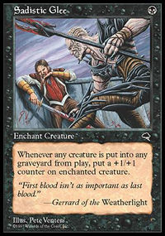
In the games, it turned out to be very important to draw first and draw one of each land of your colors and then to never draw a land again. The last was probably the most important thing. As everything was one to cast and there were only very few cards that could use extra lands in the late game a lot of games were decided by one guy just drawing one or two more lands and then dying to one 1/1. First round, I played Chris Benafel who chose to play g-u. I took the first game but had mana issues in the second and lost to Predatory Hunger in the third after I failed to draw any enchantment or creature removal as he dropped the Hunger turn 2. Next up was Antoine Ruel with b-w. He destroyed me in the first game with Sadistic Glee. I boarded it in and killed him in game 2 with it. In game 3 he never saw a swamp and I walked him over before he got going. The last round in this format was against Dave Price. He built a r-w deck. He got a turn 1 Jackal Pup in game 1 and protected it with some enchantment stuff and a Resistance Fighter and it went the distance. I won the second game and he had mana issues in the third.
Matches 2-1, Games 5-4

5-Color

In the second game, my ante was my Black Lotus...
The major problem with this format was the way the winner was determined. You'd think that you win the match if you win 2-1. Yeah, right. But Randy Buehler didn't think so. As we could not play for real ante as most of us didn't own the cards we played with, he thought that ante should have an impact anyway. So the winner of the match would be the player who won more card-value in ante. So if you lost a match 2-1 but mana-screwed your opponent in the third game when he had anted a Mox, you'd win the match.
I didn't really test this format, as Apprentice doesn't support 250 card decks and no one in Germany has a 5-Color deck. I basically took all the duals and good artifact mana, put in 18 red, green, white and black cards and filled the rest with blue card drawing and countermagic and a Mind over Matter/Academy/Urza's Blueprints/Stroke of Genius/Braingeyser engine for the win. Basically Mind over Matter/Urza's Blueprints means that you automatically win as you are allowed to play four of the most insane Magic card ever printed - Contract from Below. My deck list is here if you care to look at a 250-card deck.
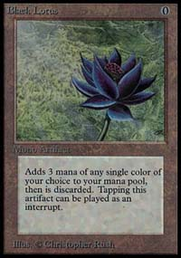
Round 1, I faced my nemesis in this format - Brian Kibler. His creatures backed up with a ton of disruption had smashed me easily when we played for fun. The first game he stalled on three lands and had only a Stormbind. When he finally reached four mana it was way too late and my card-drawing had got me Mind over Matter and Brian scooped. I won a dual-land in the ante. In the second game, Brian drew lands. In the third game he wasn't mana-screwed either. Which translates to me not winning any of those games. In the second game, my ante was my Black Lotus. A Jewelled Bird corrected that problem quickly and in the third he did not ante enough to get past his dual-land and I never cast contract and there was no way Brian could win the match even after smashing me 2-1 and won the next three games easily that we played for fun. Randy's rule struck for the first time - but it should come up again.
Kamiel was my next opponent. He played a Domain-deck with Destructive Flows and Back to Basics without any power cards. His draws were poor and my deck was very good against other control-decks, so I beat him quite easily. Mike Pustilnik was the last in line for this format. He was playing a weird creature-deck with Benalish Emissaries, Avalanche Riders, Ravenous Baboons, Tradewinder Riders and Man o' Wars. He didn't really get going in game 1 and I won that one. In the second game, I lost without any permanents in play after his deck got the land destruction engine going. Unfortunately he won a card that was worth 3 USD more then the one I won in game. That meant that all he needed to do was to get a Jewelled Bird and win the match. Then he took a one-land-mulligan which I took as well (the mulligan-rule is quite difficult with 250-card decks). His new hand held only a basic forest. He kept that and got horribly mana screwed.
Matches 5-1, Games 11-7
We finished that day at about midnight after we started at 9 and Kamiel and Tom stalled the whole thing for almost an hour as they didn't have 5-C decks ready and 5-C in general takes forever. I wasn't sure what to play in Standard and threw together a u-b Opposition/Static Orb-deck that was a small modification from a version that John Ormerod gave me after he saw Odyssey. The first format of Day 2 was draft though.

Rotisserie-Draft
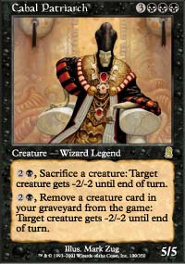
In this format, a whole set is on the table and then player basically Rochester-draft, wheeling back and forth until all cards are drafted. There were two draft pods and I was in the one with Tom van de Logt, who was first with 5-1 right now and he chose to get seat 8 as the first wheel was supposed to be very good. I chose seat 7 and it went back that way until the last guy got stuck with 1. My first pick was Cabal Patriarch after Chris Pikula was the only one to take a black card with the 4/4 flier with built-in Giant Growth. Tom wheeled two green cards and I picked up the Serra Angel/Lord of the Pit-thingy next. Then I concentrated on picking white cards as there was no one but Chris in black and he apparently had the same idea as he started picking mainly blue stuff so that the good black cards stayed longer on the table then they should. Eventually Tom jumped into black but at that point the damage was already done and Chris and I ended up with very good decks. My power cards were in addition to my two first picks a very late Shadowmage Infiltrator which our b-u mage (Mr. Pikula) apparently didn't like that much so I splashed it and Diabolic Tutor to get the Patriarch. I felt that the cards I got were quite good and I had a decent shot at winning the pod as the second best deck was Chris Benafel's and I had already played him.
That would not happen, as round 1 Scott Johns gave me a beating with Kirtar's Wrath and Kamahl, Pit Fighther. When we sat down, both of us were convinced that I had the better deck and my turn 3 Finkel in game 1 easily went all the way. In the second game, I kept 5 lands, the Nomad Decoy and an Egg. My next six draws gave me 1 spell and 5 more lands and I lost in a hurry. Game 3 I put the Patriarch out turn 6 with two lands in my hand. Scott Wrath'ed. I drew a land. He dropped Kamahl and smashed me for 6. I drew a land. He attacked for 6. I drew a land and died on his turn. Sigh. So much for the 3-0 plan. Second round I played Olivier Ruel. I have never ever beaten him. At 2000 PT-NY he beat me in a Rebel mirror. In game one, he killed me with a Reverent Mantra and in game two he used two of them to win. I never saw a single one of my four. After the match, he told me he had two Mantras in his deck. At Euros two years ago, he beat my Tinker deck. He dropped plains, Underground Rivers, Adarkar Wastes and Gaea's Cradle while searching from a Ramosian Sergeant all the way up through Lin, Skyshroud Poacher to Deranged Hermit while Annuling or Rewinding (generating mana with Cradle of course) my spells and finally locking me down with Opposition. Frown. I was out for revenge.
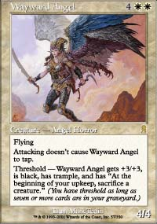
The first game a turn three Finkel followed by some other goodies was too much for him even though he had a turn 6 Aboshan. In game 2, he mulliganed twice. On turn 5 he had no cards in hand. He drew Concentrate. Next up was the 4/4 flier. I was killing him on my next turn even though I was on only two life by now. He topdecked Upheaval and won a close race afterwards. He was dominating the 3rd game with the Cephalid tap-machine. But I had my Angel, a Hallowed Healer and the Decoy in play. I cast Diabolic Tutor and got some other stuff in the bin with some chump-blocking. He had bounced the Cabal Pariarch and kept tapping one of my 3 black sources during my upkeep with his Lord. I used the black to cast Afflict, getting me threshold and Cabal Pit to finish off the Lord. The now transmuted into a 7/7 black trampling beatstick, the Wayward Angel gave him two turns to topdeck his Upheavel, but he didn't. The third draft match was rather anticlimactic. Tom van de Logt discarded in game 1 with two forests in play and drew about 10 lands and 3 spells in game 2.
Matches 7-2, Games 16-10

Standard
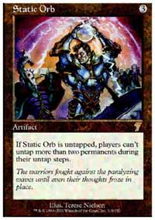
Since I played it first at German Nationals, I have loved Opposition/Static-Orb decks. As the Invitational used Odyssey cards, that meant that there was no more Thwart, Foil or Gush. So a second color could be added easily. My version of John's deck can be found here. Gary Wise was my first opponent. He had not really tested and had no choice but to throw a b-u-g control-deck together without really testing it. I had a great draw with two Duresses and turn three Finkel in game 1 and he drew way too many lands in game 2. I played against Dan Clegg and his b-u-w control-deck in round 2. First game he had to Paris and my draw was nuts again. Duress, Vodalian Zombie and an Infiltrator showed up on my side and Dan had no real answer. I got a Magpie down in game 2 and he shrugged and tapped out for Dromar, the Banisher. I had nothing but a Memory Lapse. My draw, the Magpie and my Looter gave me only another Lapse. The three cards I saw next turn did not help either and Dromar hit play. I Looted into another Magpie and passed the turn. He played a Fact or Fiction main-phase which I split into Fact or Fiction, Vindicate and Land, Land, Dromar. I hoped that he would pick the two spells and tap out for the Vindicate while I was holding a Divert. He picked the Dragon. I did nothing and passed the turn. He attacked with Dromar and I went to 14. Then he tapped 6 mana. And played a 2nd Dragon! Dromar, THE Banisher. The second one was apparently fake or so as it was buried immediately. I drew 2 cards with my Magpies, dropped a 3rd and built up enough creatures to swarm Dan over the next two turns. Chris Pikula was my last opponent for the day. Another 5-1 would push me in a great position for Top 2. It would not be. First game I kept a hand with 2 islands, a Counterspell and a Looter. He killed the Looter and his g-r beatdown-deck made short work of me afterwards as I never saw a non-island land. Second game was not much better as I did not have an Opposition or countermagic for his two Skizziks on turn 4 and 5 and I lost in less then about three minutes.
Matches 9-3, Games 20-12
Surprisingly we finished before 10 pm and I went out to have some real food after eating only fast food on Friday. I had a great steak and Andy Johnson had a lobster-plate which was absolutely ridiculous for like 6 dollars. We had some good Magic chats in general and about the auction. Before I went to bed, I goldfished some of the auction decks on Apprentice as I never really looked at them before. I realized that I probably wanted to have either the Knights, Bears or Legends. Any of the reasonable creature-decks with 7 cards would do it too I thought.

The Auction
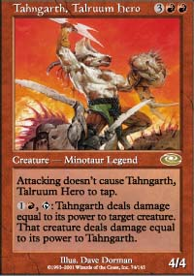
Early on, some of the powerful decks like Chimeras, Knights and Bears went for pretty high bids so I got ready to go down to fight for the legends as that was the only deck left that I really wanted. When it was eventually up for bidding there were only a few people left. I got it for 5-10 which means I would start each game with 5 cards and 10 life. Maybe 10 life was too low but I really liked the deck. About 30 mana sources gave me some hope I wouldn't get screwed too badly and it has a four Birds and a full set of Moxes for acceleration along with a Sisay, three Eladamri's Calls and two Tangarths as cards that were tough to beat for any deck.
First round I played against Jon Finkel with the Lord-deck. I had to Paris in game 1 and he put on some pressure with Lord of the Undead and Zombie Master. The real problem was his Keldon Warlord though. I got Orim, Samite Healer in play which stabilised the board a little. Then he dropped Volrath's Laboratory and named Zombies. Like the good player I am, I topdecked Tangarth and I shot down his Lords while he started to make zombies. Two turns later, I drew a Call and got Sisay. Even though he drew all three Keldon Warlords in his deck, the Captain took over and after a combination of Tangarth, Karn and Sword of the Chosen got rid of his laboratory Jon scooped. In the second game he followed up my turn 2 Sword of the Chosen with Goblin King. I dropped Squee! I attacked for 4 and Starke of Rath hit play on my next turn. Unfortunately, I drew mana for a few turns and he put out some really big guys. Then he played Chaos Lord, a 7/7 creature that deserts to your opponent if the number of all permanents in play is even. I had three moxes in play and drew Karn, Silver Golem. I realized it one turn too late that I could steal it by just killing my moxes as I thought it were just his permanents. I corrected that the turn after though and my trusty Squee served for the last few points of damage while his Lord helped me stabilize the board and make sure my two life points would carry me through.
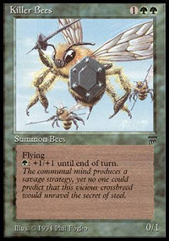
At this point one, more win would almost guarantee a Top 2 finish, if I would lose out I needed Dan Clegg and/or Scott Richards to lose one of their remaining matches so that it would come down to a tiebreaker, which I would probably win. Next up was Tsuyoshi Fujita with the Bear-deck. He went down to 4-17 to get it. I won the toss and chose to draw. I felt that I should definitely win this matchup as my deck had four Mirri, Cat Warrior. Tsuyoshi didn't agree though. Game 1 he went forest, forest, Bear, forest, Bear, forest, and cast the ONE Killer Bees that were in the deck. On my fourth turn, I dropped Tangarth. But he missed no land drops and could safely swing with the Bees for two and still protect it. Next turn, I died to the Bees. I chose to draw for the 2nd game again. He Parised to 3. My hand was Mox Emerald, Lay of the Land, Eladamri's Call, Tangarth, Legacy Weapon. He played a forest and passed the turn. I drew my 2nd Legacy Weapon and fetched a plains. He dropped a Grizzly Bear. I did not draw a land again and passed the turn. He attacked and passed. I Called for a Bird, did not draw a land, dropped the Bird and passed. He attacked and cast Drop of Honey with one card in hand. I failed to draw mana again and passed the turn. My Bird died, he knocked on his library, got the land he needed and dropped Striped Bears. Next turn he had another Bear to fuel the drop and I died.
Scott Richards and Dan Clegg both won and it came down to my last match against Scott. He was with the Dwarves on 7-20. We were both quite nervous and in addition we had to wait ten minutes until Matt Vienneau showed up (he was away drinking probably) to cover our match. I expected Scott to slaughter me. His deck was quite fast and very consistent. In game 1, I drew the nuts though. Turn 1 Bird, turn 2 Mox, Harrow, Call Tangarth, turn 3 drop Tangarth. Two turns later, he scooped. Game 2 was the opposite though. I Parised and he had a turn two power 2 dwarf and a turn 3 Lieutenant and killed me before I got going. A turn 3 Squee was pretty good for me in game 3 on the other hand. He still brought me down to 2 life. He had a 2/1 and a 1/2 that gives +1+0 to dwarves for and I had Squee and Bird. We both drew lands for a few turns and no one could do anything. He kept attacking with his 1/2 and I kept blocking and recasting Squee. Then I drew Tangarth. I couldn't cast them both though. The Lieutenant was really annoying me and so I thought my best try is to trade Tangarth for him. I dropped it, he apparently drew another land and attacked with his dwarves. Tangarth blocked the pumper and the Bird jumped in front of the 2/1. Scott shrugged. And put the Lieutenant in the bin. And passed his turn. He was so annoyed that he drew a land almost every turn that he forgot to pump it. Tangarth attacked and killed the other dwarf. Then I dropped Squee. In the meantime, he had 2 storage lands in play and so he had a lot of mana. He also had four Dwarven Catapults in his deck. He went down to 6 and I drew Gerrard. I cast it and he topdecked a Catapult and killed all my guys with a Catapult for 12. I replayed the Squee and it beat him for 2 turns while he drew another Catapult. Then I drew another Tangarth which died to his second Catapult. I topdecked another Call and dropped Squee and Mirri. He drew another and extended his hand to congratulate me for making the finals!
Boy, was I relieved to win that game!
Matches 11-4, games 24-15
Dan Clegg also won his match and finished with an 11-4 record as well. Scott Richards and Kamiel were 3rd/4th with 10-5 records each. That meant that Dan and I would face off for the right to get our own card printed. In the meantime Day 2 of the GP was going on and Andrew Mitchell was dominating the Swiss with a 10-0 record. TBS was also in a good position while Ryan Fuller needed to win out to make it in.
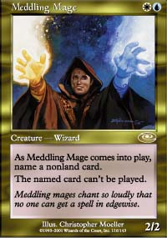
We agreed that 5-Color should be the last format in the finals, as it would take up the most time. The order was Standard, Auction, Rotisserie, Duplicate and finally 5C. The first format was a rematch from round 11. I won the coin toss (which I did all weekend against Dan) and chose to play first. My draw wasn't great though and by turn 6 Dan had all FOUR Meddling Mages on the table - naming Shadowmage Infiltrator, Opposition, Thieving Magpie and Repulse. As I had no bounce maindeck I could never get out of that and scooped after I tried to Loot into enough creatures to swarm him. That didn't work out. The second game looked pretty bad as well, when Dan dropped an Infiltrator after he Duressed my Counterspell and all I could do was to answer with a Magpie. He drew two cards and then after about five minutes decided to Vindicate my Magpie. I topdecked Repulse and hoped to draw into a land so that I could drop another Magpie right away as I had a Familiar in play. I drew Opposition though. Dan just replayed the Infiltrator and I drew into Gainsay to force the Opposition past his Gainsay. My two following Magpies both hit play and I won soon after.
In the third game a Vodalian Zombie traded with Meddling Mage and when I Duressed Dan I had a swamp, island, Underground River in play and my hand had no more land but I was holding a Gainsay, a Counterspell, an Infiltrator and something random. In response to the Duress he Recoiled my untapped island. I floated a blue and looked at his pretty poor hand - a Dromar and two Disenchants while he had four lands in play. I took a Disenchant, replayed the island and dropped the Wizard. Dan drew a land and when Dromar was Gainsaid next turn and I followed up with a second Infiltrator with a Counterspell in hand it was all but over.
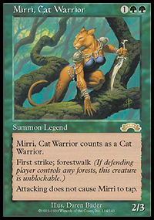
I thought that I had a huge advantage in the second format - Legends against Spies. He had something like 6-17 and he didn't have much to apply pressure with. If I could get out a Mirri, he would be on the ropes. In the first game he got some beatdown with some 1/1s going but a turn four Tangarth shut that down and won the game shortly afterwards. The second game was weird. I got a turn one Squee, Goblin Nabob, but I had nothing but lands afterwards. I cast all four Lays of the Land in the course of the game. Dan didn't draw any business spells either and when Mirri hit the table, he could do nothing but watch me draw a Call and play Sisay. A few legends later, I was leading 2-0 in formats.
Rotisserie was up third. The problem here was that we were drafting at different tables. As he was b-u while I was b-w, there might be duplicates in our card pools which generally should not happen in this format. It was especially bad that both of us had Cabal Patriarch and neither of us had removal for that guy. Since it is a legend, whoever cast it first would very likely win. I thought I might have an advantage because I had Diabolic Tutor but Dan evened that out with a couple counterspells. In the end, I got the Patriach out in game 1 and he had it on turn 6 in both games two and three. So he won 2-1.
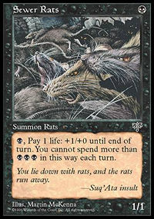
Fourth was Duplicate Limited. Both of us chose to run a b-w deck there. It was largely the same cards with few differences, so it totally came down to the better draw. In game 1, I didn't get a black mana until about turn 12 or so but Dan didn't have a great draw either and when I could finally cast the six black spells in my hand, I just barely overwhemed him with 3 life left. I had to Paris going first in game 2 and the cards I got afterwards were six lands, Mana Cylix, Sewer Rats, Unholy Strength and Erase. Not quite good enough unfortunately. In the third game, Dan stopped drawing lands with 2 plains and a swamp in play while I drew about six lands and that is almost impossible to beat in this format.
So it would all come down to the fifth match - 5-Color. And unfortunately for me, Dan was playing creatures there. I knew that my deck couldn't deal with creatures. Brian had smashed me again and again. So I went up to my room rebuilding my 5, hoping that I might luck it out with the Buehler-ante by winning one game and getting a card that is more valuable then my ante in the other two games. The first game looked horrible for me. I had no mana acceleration and a bunch of cantrips. I did go first though, which helped a lot. Dan got a Mox Diamond, some lands, dropped two shadows and put Rancor on one of them. When he had emptied his hand he tapped out for Contract. I used about 10 minutes for my turn. I was one mana short of using Time Warp to get another land in play and using an array of tutor-effects to get Mind over Matter in play, which would very likely win the game with the Sol Ring I had at that point.
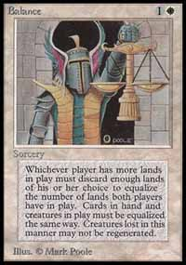
It just didn't work out on the turns and I did not want Dan to untap as he was definitely running discard and very likely Armageddon too and I had nothing to stop that from happening. I tried to figure out how I could at least kill the creatures, used the Time Warp and played Mystical Tutor during my upkeep. Mark Rosewater offered to help me search and I said he should look for my Fireball. When I went through the library I saw the Balance. I looked at my hand and had to laugh. Balance it was. I got a Sky Diamond with an Opt, played it along with Barbed Sextant, Jewelled Bird and a land and balanced with only a Fact of Fiction in hand and two artifact cantrips on the table. Dan went down to one creature in hand, dropped that and Rancored it up next turn. Between my next draw phase, the Bird and the Sextant I got a Fire/Ice though and killed it right away. Dan's next creature was countered and I spent using cantrips, card drawing and countermagic over the next few turns until I sacrificed my Black Lotus to cast Yawgmoth's Will with about 50 cards in my graveyard. I explained to Dan how I would get Mind Over Matter in play and he scooped. Thanks to his Contract, I won slightly more then 5 USD in ante and that meant that two Jewelled Birds would clinch the match for me.
When we turned over the ante for the second game Dan managed to get my Black Lotus. That meant that I desperately had to win or get a Jewelled Bird. I did some pretty amazing topdecks like a Wall of Blossom when a Carnophage was beating me down and I had a Force of Will for his Contract. I drew cards like a madman but still a Frenetic Efreet resolved with me having about seven life left. When I was down to 1 life I resolved my second Allied Strategy for five cards but it only got me three lands and two Uktabis. I could have used a Contract and try to find something but instead I just used a Jewelled Bird and conceded the game. A good choice as my top card was a dual and the next seven would not have produced an answer. So it came down to game 3. Which was game FOURTEEN out of the 15 possible games that it could possibly take. By now we were playing the finals since more then seven hours. The Swiss of the GP was long done and saw Andrew Mitchell, TBS, Justin Polin and Peter (the winner of the trial) in the Top 8. That also meant that we got some more spectators. Apparently word got around that this was the deciding match. I drew my hand and it had no Jewelled Bird and only one land, so I took a mulligan. Dan decided to take the freebie and drew a new hand too. My next hand was alright but not great with 3 lands, a Tithe, a Wasteland, a Wrath of God and a Force of Will. I drew a land, dropped a white dual and passed the turn. Dan played a Plateau and then pitched a Land Grant, revealing me Soltari Trooper Dauth Slayer, Dark Ritual, Dark Ritual, Hatred. I looked at the Wasteland in my hand and at the Force and thought that I was probably in a decent shape. I drew my card for the turn. A blue card. Instead of using the Wasteland I dropped the Fellwar Stone and passed the turn. Dan dropped the Soltari Trooper with the Hatred Kill waiting in his hand. The spectators who could not see my hand were trying to figure out if I could deal with that. I drew my card, tapped my two lands and the stone and won the match on my 3rd turn. How you ask?
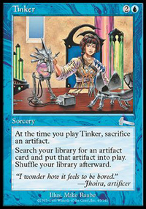
With Tinker.
What did I get you wonder?
Nah, not a Triskelion, a Blueprint, a Phyrexian Colossus or a Crumbling Sanctuary.
I got a Jewelled Bird.
I exchanged the ante, conceded the game and won the match 1-2 on 1 dollar and 50 cent.
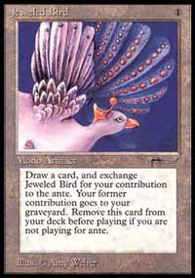
Doesn't that seem totally wrong somehow? Dan and I played for about eight hours and then it finished like this? I am pretty sure that Kurtis Hahn, the inventor of 5-C, was excited when they chose his format for the Invitational. I don't know how excited he was when he read how I won. I can't imagine that Tinkering up a Jewelled Bird and throwing a game away to win on 150 cents on ante value is in the spirit of 5-Color. Anyway it was of course great to win. The Invitational was the one tournament where I have not done very well in the past and I felt excited to win, even though the way I did was not all that great. Getting your own card printed is probably what every player dreams of. I am already quite excited about what my card will look like. I doubt that my original card will make it:
Wisedrafters Will
Enchantment
Opponents play with their hand revealed
, sac: draw a card
, sac: counter target spell
As it is probably just straight better then counterspell and I am not sure if WotC wants to see that. Quite a few people told me that I should make a creature cause it is great to smash people with yourself. Sounds like a good idea. I really hope that it is going to be on the same power level as Meddling Mage and Shadowmage Infiltrator as those cards have or will change Standard on their own.
While we were eating at a nice Chinese place, TBS was busy slaughtering people in the Top 8 of the GP. We went off to the lobby of the hotel and did a draft until about 4 am when I almost fell asleep in my last match. I went up to my room and TBS was sleeping on the floor. He woke up when I got in and when we looked at the trophies we won, we had to agree that this room was definitely the place to stay this weekend.
If you made it all the way up here, I'd like to thank all those great people from WotC UK and South Africa who made the Invitational and the Grand Prix as good as they were and for putting up with us and showing us the city from Monday to Wednesday.

